Ben Lauzon

4/01/2021

**Mid-Project Report: CV2X Implementation on Unique Vehicle Body Styles**

**Introduction**

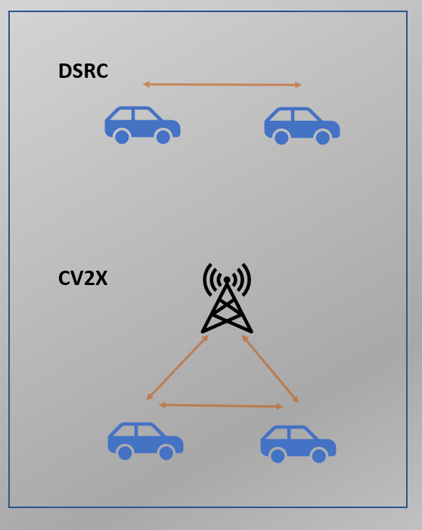V2X is a quickly emerging vehicular communication system. It stands for Vehicle-to-Everything, which includes communications from a vehicle to things such as cars, infrastructure, pedestrians, and much more. There are two types of V2X technologies; WLAN-based and cellular-based (CV2X). WLAN-based requires direct, line of sight, communication between two antennas. CV2X allows for direct, line of sight, communication between antennas or allows the signal to be bounced off a cell tower before redirecting to the second antenna. This means CV2X is not as line of sight dependent and can be used in a wider number of applications. Most vehicle manufactures have opted for CV2X for this reason.

**Problem Statement**

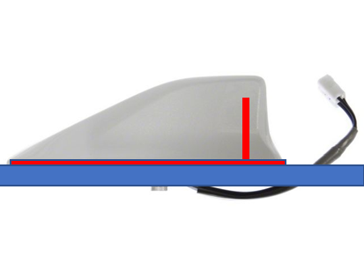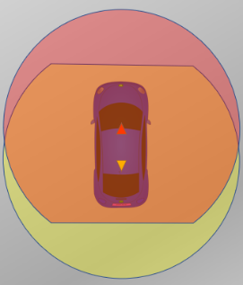CV2X signals cannot see through obstructions well and rely on a good line of site to an object or tower to function effectively. Applications rely heavily on a forward and rearward looking antenna to form a 360° view around the vehicle. The easiest way to achieve this is with front and rear roof mounted antennas. Roof mounted CV2X antennas are typically mounted inside a vehicles “sharkfin” style antenna. It is a monopole element that uses the vehicles roof sheet metal to create a dipole antenna. This antenna creates a round pattern and is extremely effective for this application. Simulations of an ideal antenna will be demonstrated later in this report. In many cases, it is not possible to package an antenna on the front and rear of a roof panel. Some examples include convertibles, vehicles with removable roofs, dump/UPS trucks, or luxury vehicles that want to hide roof antennas for a better studio look. This requires the implementation and development of new and unique antenna designs and packaging.

This report will show simulations of three types of CV2X antenna system proposals including an ideal roof mounted antenna system, CHMSL / Front windshield diversity antenna system, and a side view mirror diversity antenna system. This will be achieved using the MATLAB Antenna Toolbox. The entire system from the antenna to the embedded modem will then be modeled using Simulink.

**Antenna Simulation – Ideal Roof Antenna**

The first design is just a simple monopole on a ground plane to demonstrate an ideal roof mounted antenna. As explained previously, this is the type of element that is inside a “Sharkfin” style antenna. The antenna was designed to resonate at 5.9 GHz. 5.9 GHz is the frequency of CV2X. The 3D antenna pattern gives a nice uniform sphere. This is further shown in the 2D azimuth and elevation plots. It is simple to see why this antenna is so desirable from a performance perspective. It is easy to implement, cheap, achieves desired patterns, and in many cases only require a single element to be packaged on the vehicle roof.

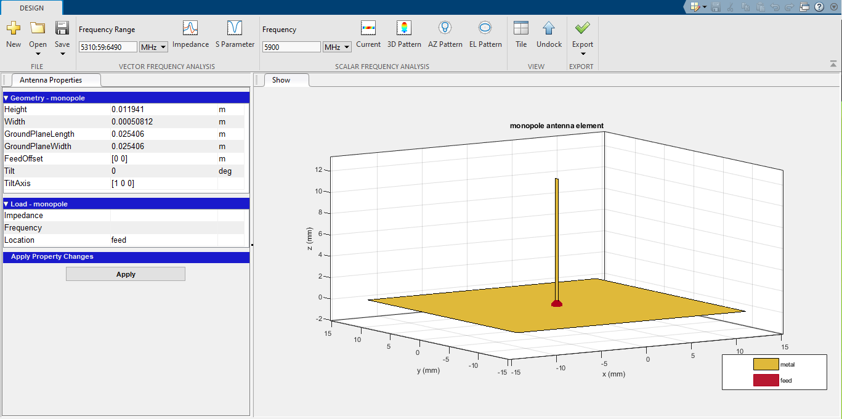

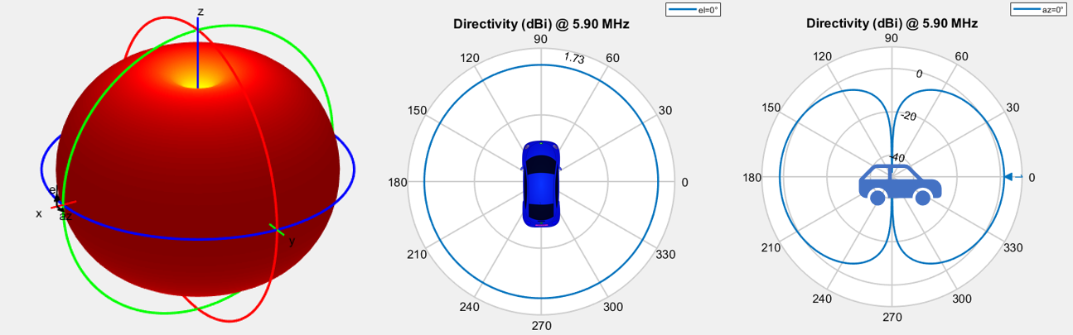

**Antenna Simulation – CHMSL / Front Windshield Antenna**

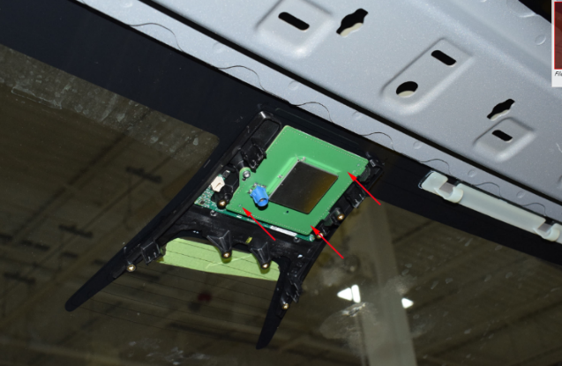 Many vehicles are unable to implement the ideal roof mount antenna system. One of the emerging packaging spaces for CV2X is the front windshield and rear CHMSL. These locations have the best view of the front and rear of the vehicle respectively. By using a diversity system, you can combine the patterns to achieve a near 360° view around the vehicle. It is important to note that the CV2X systems are mostly concerned with front/rear view and allow some flexibility with the view on the side of the vehicle. This is because most of the use applications are concerned with what is in front or behind you. This means that an oval shaped diversity pattern is acceptable. A range of different antenna styles were simulated and a Vee style element with a metal backing plate provided the best directional radiation pattern for this application. As can be seen in the 3D plot, the antenna is radiating most of its power in a single direction @ 5.9 GHz. It is a similar story when we look at the 2D azimuth and elevation plots. When the 2D plots are overlaid to simulate a forward windshield package and a rear CHMSL package, an oval-like 360° is achievable.

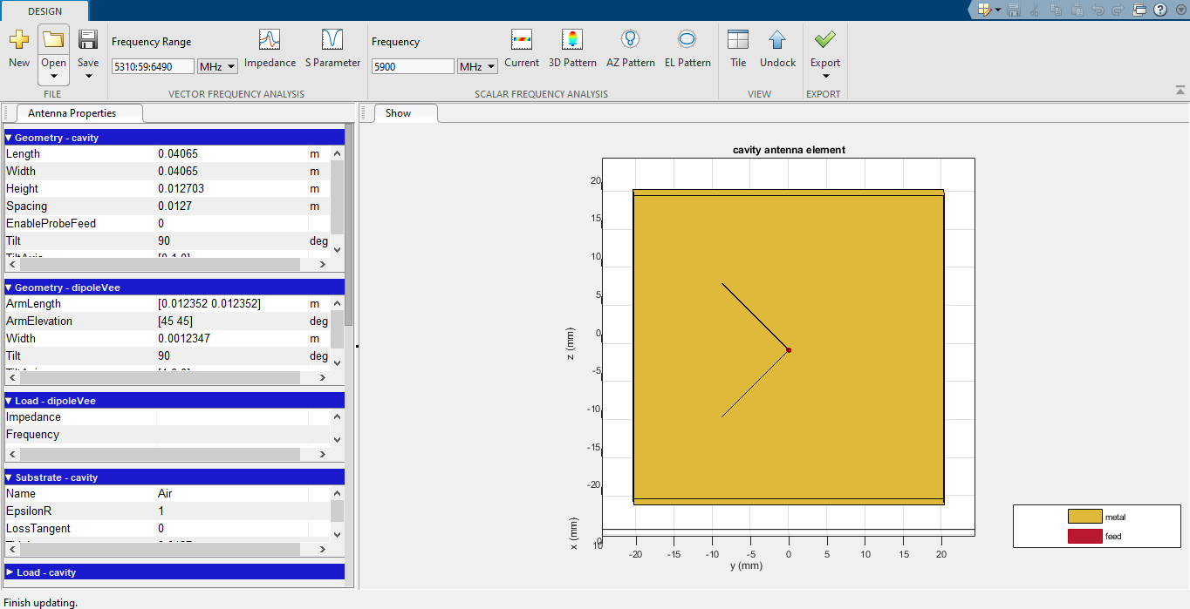

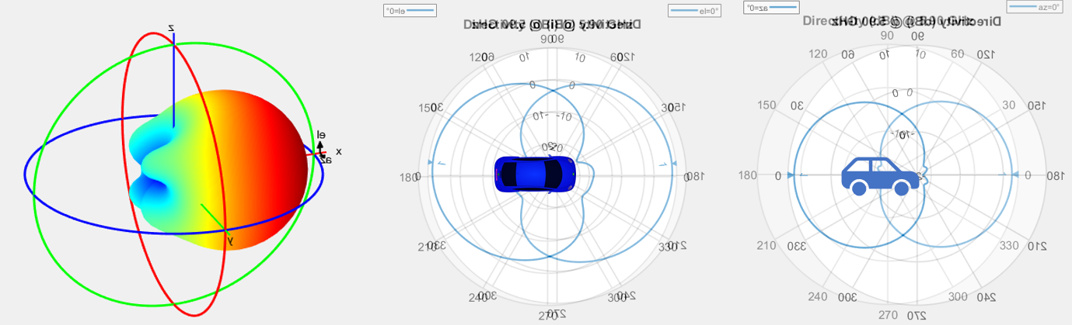

Side Mirror Antenna

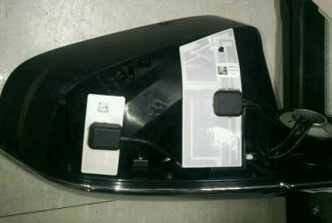Another location to mount antennas is in the vehicle’s side view mirrors. This package location is commonly used today for AM/FM, Cellular, and WiFi antennas. CV2X antennas are very small due to the high frequency they operate at. This means it is very achievable to package the antenna in the side mirrors. By placing an element in each side mirror, a diversity system can be used to combine the patterns and achieve the 360° view. The elements need to be designed so that they radiate mostly in the forward and rear direction. A circular style element was the best at achieving this pattern. This element would be placed on an RF transparent material and mounted vertically within the mirror similar to what is shown in the picture. From the 3D simulation, the antenna radiates its power forward/rearward @ 5.9GHz. The 2D plots were then overlayed to demonstrate what the pattern would like in a diversity system with an element in each mirror. It can be seen that the desired 360° degree oval shape is achieved.

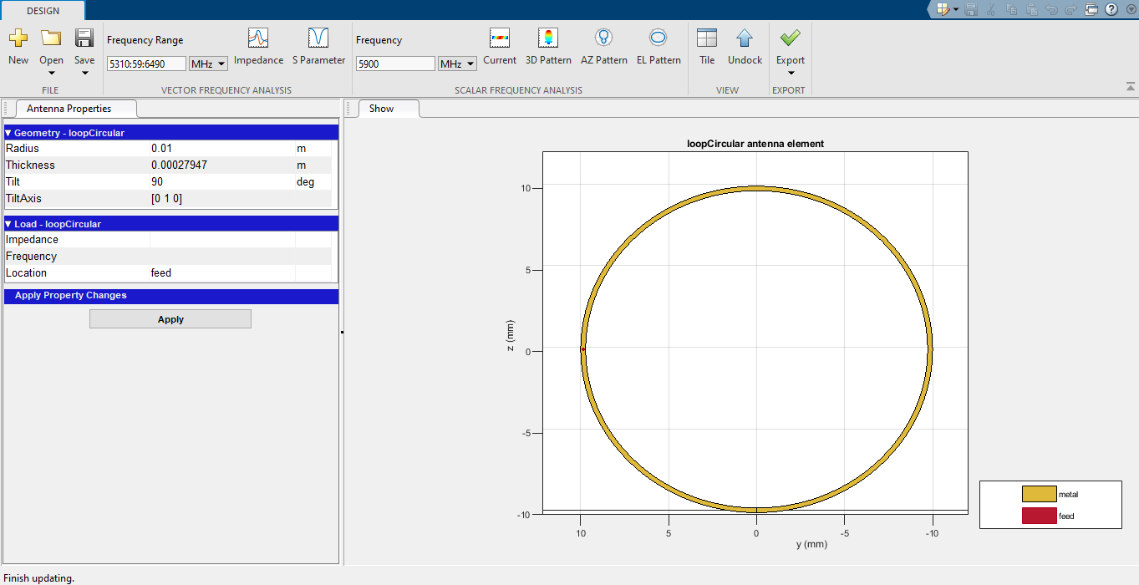

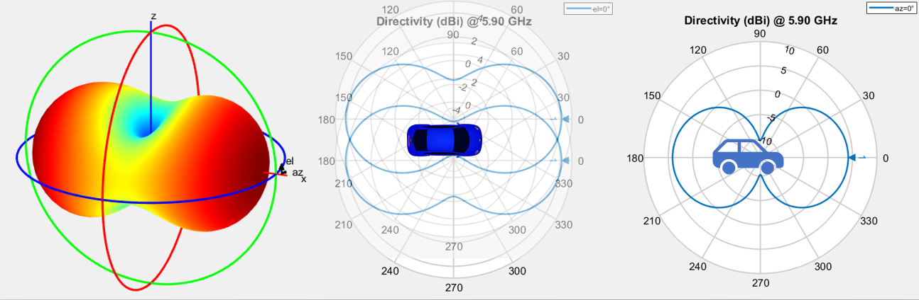

**Simulink Simulation of Antenna System**

The vehicle antenna system consists of more parts than just the antenna element. Once the antenna receives the signal, it must travel to a telematics control unit (TCU) where the data can be processed. In order to achieve this, the antenna signal needs to be amplified, travel along the vehicle coax, and be filtered at the TCU. The SAE spec states the minimum sensitivity at the receiver is -92dBm for MCS 11 (16-QAM). This means that at the TCU the signal level must be greater than -92dBm to be an effective CV2X system.

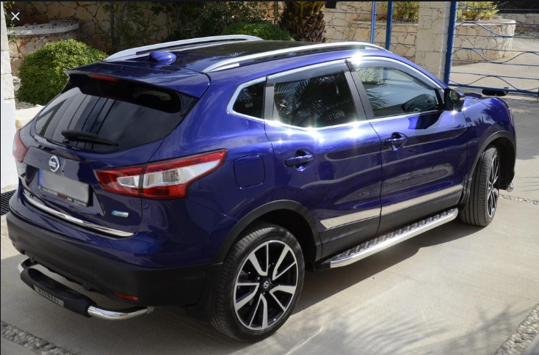

TCU

The MATLAB RF budget analyzer can be used to simulate this system. It allows the user to create an antenna element, define the S-paramaters for the antenna, design an amplifier, simulate coax path loss, and design a filter at the TCU. Once all the elements are designed, the diagram can be exported into Simulink. From Simulink, the entire system can be run. In this case, a -120 dBm signal was inputted into the system. It is converted to an RF signal and picked up by the antenna element defined by the S-parameters taken from the antenna designed in the MATLAB antenna toolbox. This signal is then amplified and sent along the vehicle coax. The coax is simulated using a negative gain block. Before the signal makes it to the TCU, a butterworth filter wass used to grab the 5.9GHz frequency of the signal. Ultimately, there ends up being a -90 dBm signal at the TCU. This outcome shows that the designed antennas are picking up the signals efficiently and the system is functioning properly. 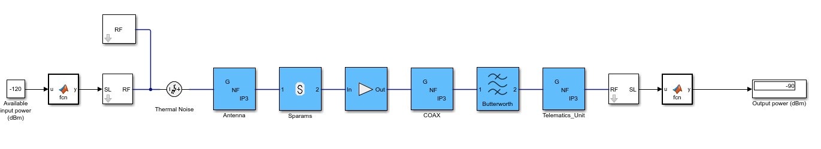

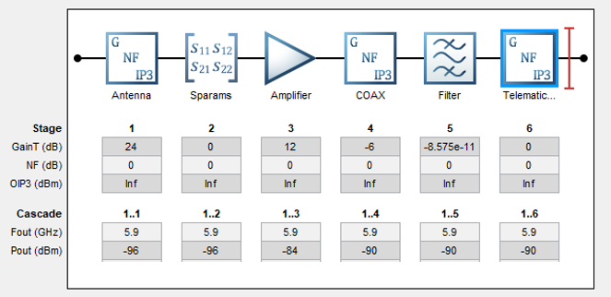

**Conclusion**

CV2X is an emerging technology that is beginning to see implementation in the automotive space. Engineers are not always given an ideal packaging situation and unique antennas need to be designed to meet vehicle level requirements. The CV2X system contains more than just the antenna itself and many variables need to be considered on any given vehicle. CV2X is a crucial step forward in making our driving experience safer and more efficient.